- Erase ESP32mini:
  - Plug the USB cable to ESP32 mini:

  - Open Flash Download tool
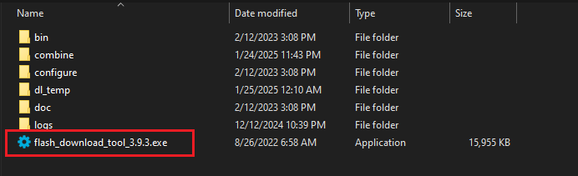

  - Select the right options
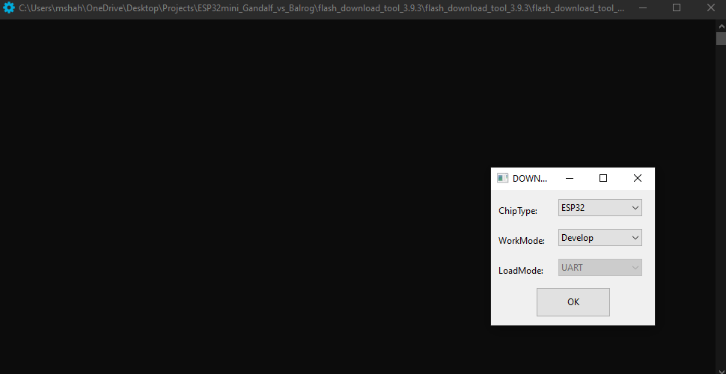
  - Click ‘ERASE’ button
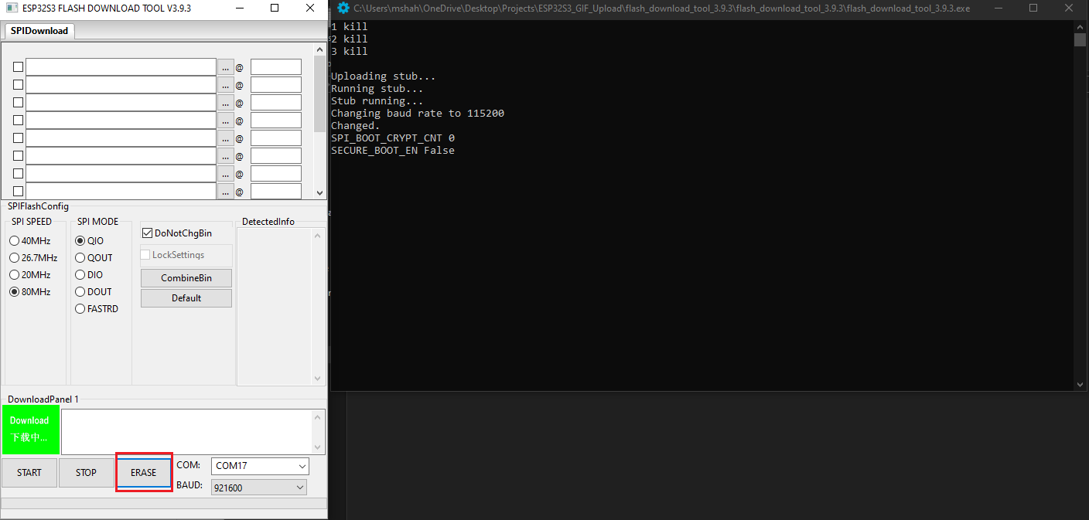
- Flash application
  - Select the required files, enter the memory address for each file and click the checkbox for each file
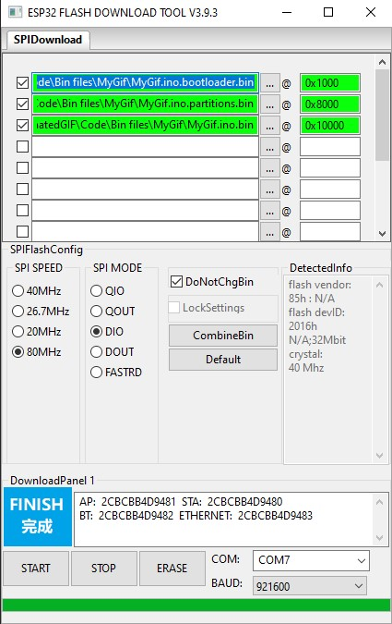

  - Click ‘START’ button and wait for the files to flash
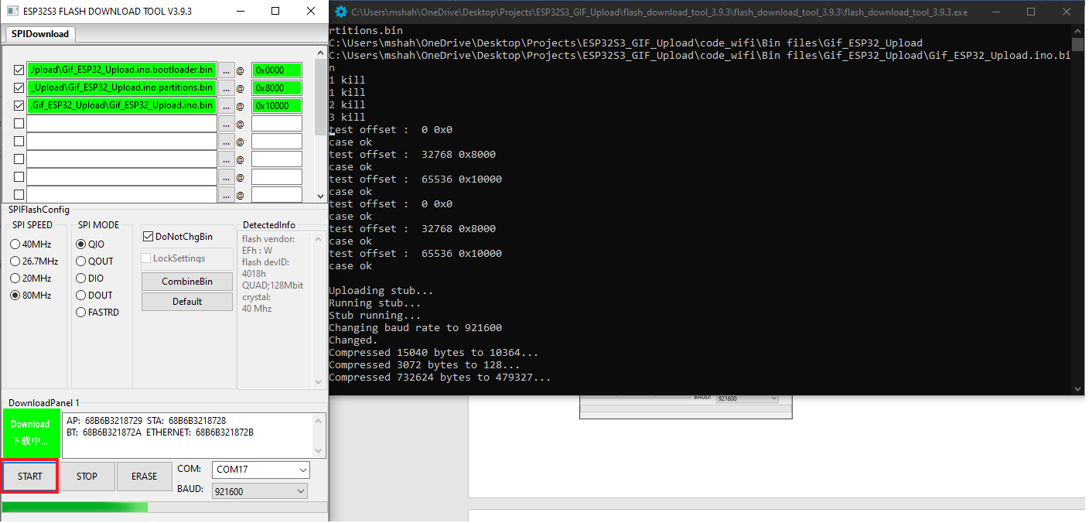

  - When the flashing is finished the status box will say “FINISH”
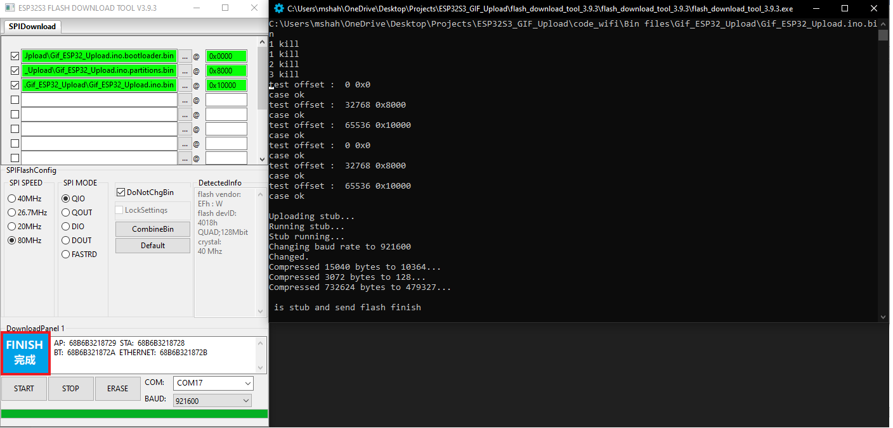

  - Disconnect ESP32 mini board and power it up again to run the application.

